RESEARCH TASK 1A

What is Model Fitting?
Model fitting means training a machine-learning model so that it can learn patterns from the data we provide. The aim is not only to perform well on the training data, but also to make accurate predictions when it is given new or unseen data. Two types:
1. What is Underfitting?
Underfitting occurs when a model is too simple to learn the important patterns in the data. Since it has not learned enough, its performance is poor on both the training and testing data.
For example, think of a student who studies only a small part of a chapter. They may struggle even with the practice questions and are likely to have trouble in the exam too. This is similar to what happens with an underfitted model.
Why does Underfitting happen?
- The model is too simple: The model may not be powerful enough to find the important patterns in the data.
- Insufficient training: The model may not have been trained for long enough, so it does not learn the patterns properly.
- Poor or inadequate features: The input features may not provide enough useful information for the model to make good predictions.
- Too much regularization: Strong regularization can limit the model so much that it cannot learn the useful patterns.
How can we fix Underfitting?
- Use a more complex model: A stronger model may be able to learn patterns that a simpler model misses.
- Add useful features: Providing better or more informative input features can help the model learn more effectively.
- Reduce regularization: If regularization is too strong, reducing it can give the model more freedom to learn.
- Train the model for longer: Giving the model more training time can help it learn the patterns better.

2. What is Overfitting?
Overfitting occurs when a model learns the training data too closely. Instead of learning just the useful pattern, it also picks up noise, small details, and random errors in the training data.
As a result, the model may perform very well on the training data but poorly on new testing data. In simple terms, it has memorized the training data instead of learning a pattern that works well on new data.
A simple example is a student who memorizes answers to practice questions instead of understanding the topic. They may do well on those practice questions but struggle when the exam contains a different type of question.
Why does Overfitting happen?
- The model is too complex: A very complex model can start learning noise and small details instead of the main pattern.
- Not enough training data: When there is too little data, the model may memorize individual examples rather than learn general patterns.
- Noisy data: Errors, unusual values, or outliers in the data may be mistaken for real patterns.
- Too many irrelevant features: Unnecessary features can add noise and make the model learn patterns that are not useful.
How can we fix Overfitting?
- Simplify the model: A simpler model is less likely to memorize noise from the training data.
- Use more training data: More varied training data makes memorization harder and helps the model learn patterns that generalize better.
- Feature selection: Remove features that are unnecessary or do not contribute useful information.
- Use regularization: Regularization limits unnecessary model complexity and helps reduce overfitting.
- Use cross-validation: Testing the model on different training and testing splits helps check whether it performs well beyond a single split.
- Use early stopping: Stop training when validation performance starts getting worse, even if the training performance is still improving.
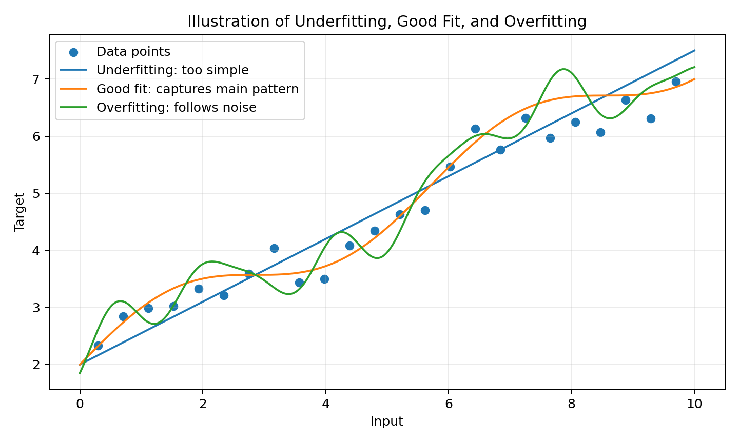
Figure 1. Underfitting uses a curve that is too simple, a good fit captures the main pattern, and overfitting follows the data too closely.
3. What are Bias and Variance?
Bias
Bias is the error caused by making a model too simple or using assumptions that are too strong. A high-bias model often misses important patterns in the data, which is why high bias is usually associated with underfitting.
Variance
Variance describes how much a model changes when the training data changes. A high-variance model is very sensitive to the particular examples it is trained on. It may learn noise and small details, which is why high variance is usually associated with overfitting.
4. How are Bias and Variance related to Underfitting and Overfitting?
Fit | Model | Bias | Variance
Underfitting | Too simple | High | Low
Good fit | Right level of complexity | Balanced | Balanced
Overfitting | Too complex / too sensitive | Low | High
This relationship is known as the bias–variance trade-off. When a model is too simple, its bias is high and it may underfit. When the model becomes too complex, its variance can become high and it may overfit. The goal is to find a good balance so that the model learns the important pattern without simply memorizing noise.
Prediction error: Total Error = Bias² + Variance + Irreducible Error. Irreducible error comes from noise or uncertainty in the data that the model cannot completely remove.
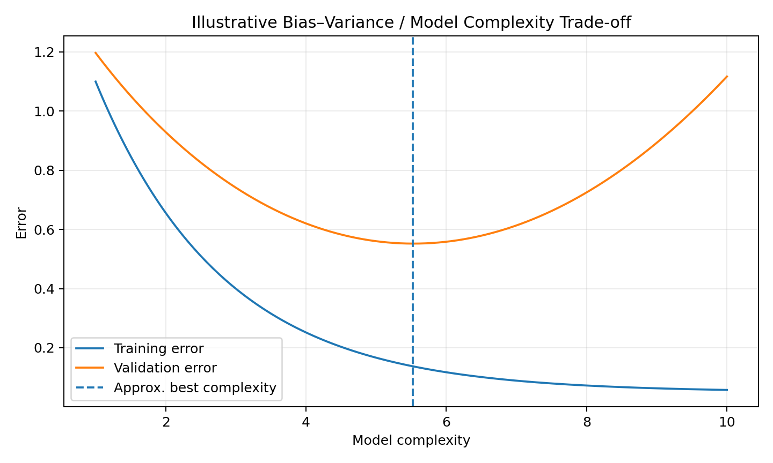
Figure 2. The graph shows the basic idea of the bias–variance trade-off. As model complexity increases, training error usually decreases, while validation error may decrease at first and then increase when the model starts overfitting.
5. How can you identify whether a model is Underfitting or Overfitting?
To identify Underfitting:
- Training performance is poor.
- Testing or validation performance is also poor.
- Both training and testing errors are usually high.
- The model is often too simple and misses the main pattern.
To identify Overfitting:
- Training performance is very good.
- Testing or validation performance is much worse.
- Training error may keep decreasing while validation error starts increasing.
- The model may be unnecessarily complex and sensitive to the particular training data.
The easiest practical method is to compare the model's training performance with its validation or test performance. If both are poor, the model may be underfitting. If training performance is very good but validation or test performance is poor, the model may be overfitting.
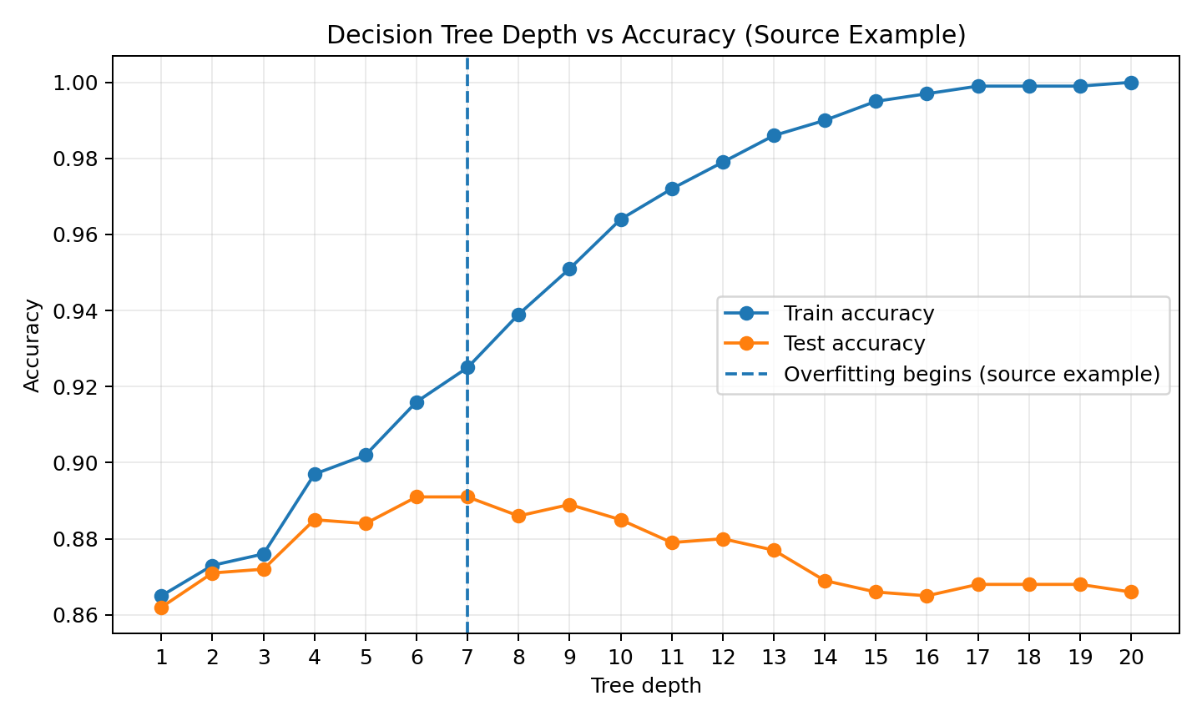
Figure 3. Decision-tree example. As the tree gets deeper, training accuracy keeps increasing, while test accuracy eventually stops improving and starts falling. This is a typical sign of overfitting.
6. Mention at least one way to deal with Underfitting.
One simple way to deal with underfitting is to use a more suitable or complex model. We can also add useful features, reduce excessive regularization, or train the model for longer.
7. Mention at least one way to deal with Overfitting.
One common way to deal with overfitting is regularization, which helps prevent the model from becoming unnecessarily complex. Other useful methods include using more training data, removing irrelevant features, using cross-validation, simplifying the model, and using early stopping.
Quick Comparison
Feature | Underfitting | Good Fit | Overfitting | What to do
Training performance | Poor | Good | Very good | Compare with validation
Testing/validation performance | Poor | Good | Poor | Check generalization
Bias | High | Balanced | Low | Adjust model complexity
Variance | Low | Balanced | High | Use data/regularization
Main problem | Model is too simple | Good complexity | Model learns noise | Tune the model
Conclusion
The easiest way to remember the difference is:
- Underfitting = the model has learned too little.
- Good fit = the model has learned the important pattern.
- Overfitting = the model has learned too much from the training data, including noise.
A good machine-learning model should not simply memorize the training data. It should learn the useful patterns well enough to make good predictions on new data.

Ram

